# Problem Statement/Description

With the development of the Internet, more and more people will choose to shop online. This online shopping system is designed to meet people's online shopping needs. The first is the login interface. There are registration and login functions. Registration can register buyer accounts and seller accounts. There are also two modes of login. In the seller mode, you can browse the shops and purchase products. If you see the right product, you can put it in the shopping cart. When an order needs to be placed, the goods in the shopping cart will be put into the order, input relevant information and pay. You can then view the order information through the function of viewing the order information. The seller will also receive orders and obtain order information at this time. When you log in in the seller mode/admin mode, you can add and remove products, adjust product prices, and view order information.

**Table of Contents**

1. Introduction 4

2. Definitions 4

2.1 shopping trolly 4

2.2 payment 4

2.3 Store 4

2.4 User 4

2.5 Booking 4

2.6 Goods 4

## 1. Introduction

This document uses some professional vocabulary to explain the problems that readers may involve or items used when reading other documents. Usually, this document can be used as an informal data dictionary to collect data definitions, so that other documents can better focus on its essential purpose.

## 2. Definitions

This glossary contains the definitions of vocabulary used in the " Online Shopping System " APP.

## 2.1 Shopping trolley

Store and record the products purchased by users, and users can add, delete and purchase products.

Payment information for the user to pay for the ordered goods

## 2.2 Payment

Payment information for the user to pay for the ordered goods

## 2.3 Store

##### Store, used to record information about the store’s products, store credit, and store products

## 2.4 User

Users, including buyers and sellers

## 2.5 Booking

Record order information, including buyer, seller, product, shipping address, transaction time and other information

## 2.6 Goods

**Products sold in the store**

## Use Case Diagram

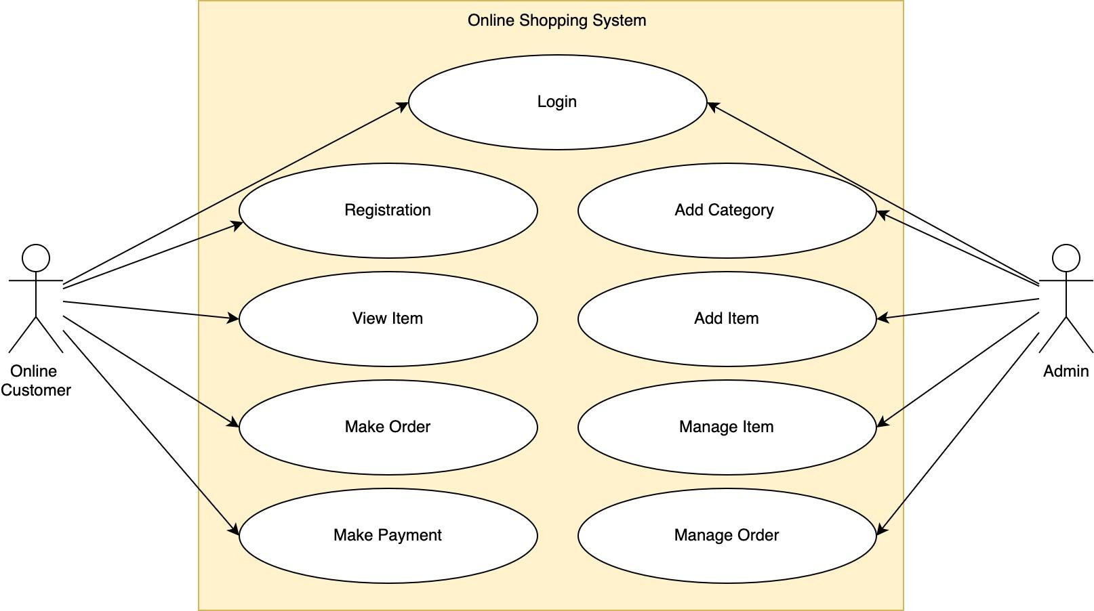

## Context Diagram

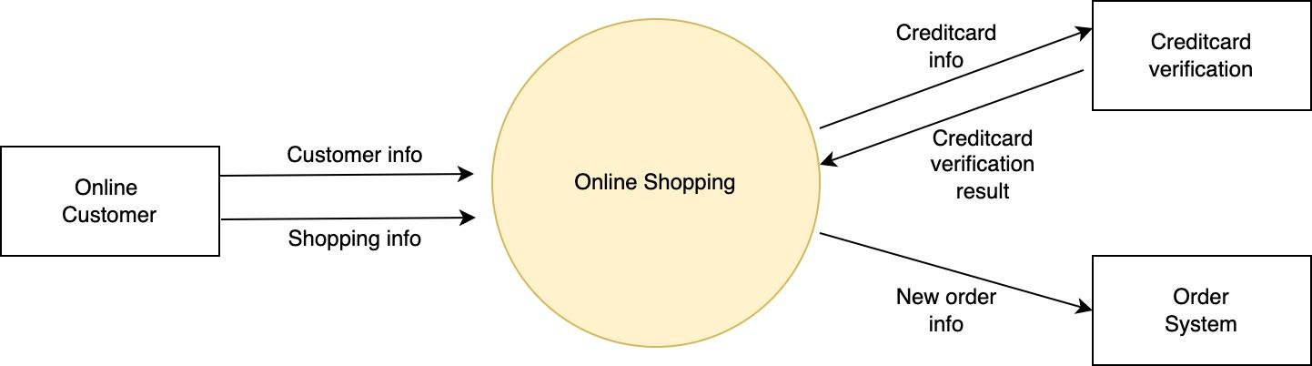

## Class Diagram

